Buttonboard

|  |  |  |  |
| --- | --- | --- | --- |
| Project (P15) | Current Rev # C | March 18, 2021 | Bryce Staver |

HARdware Documentation

Prisum solar car

2021

|  |  |  |  |
| --- | --- | --- | --- |
| Revision History | | | |
| Rev # | **Description** | **Hardware Manager** | **Approved By**  **Need 2/3 for approval: eteam director or assistant director, eteam manager, or alumni** |
| P14 Rev | P14 buttonboard | Bryan Kalkhoff |  |
| Rev 1 | Reworked buttonboard from P14 and simplified it a ton. This was started as a new member project Fall 2020. Most of the changes were done here. | Bryce Staver | Bryan Kalkhoff, Ashley Robertson |
| Rev 2 | We changed the 12V connector to a Megafit and added a reverse polarity protection. | Bryce Staver | Bryan Kalkhoff, Ashley Robertson |
| Rev 3 | Added input debouncing and power filtering for 12V_Main coming into the board | Bryan Kalkhoff | Douglas Zuercher,  Ashley Robertson |

Contents

**Theory of Operation 3**

**Description 3**

**Board Placement 3**

**Purpose 3**

**Application 4**

**System Level 4**

**Block Diagram 4**

**Pin Diagram 5**

**Board Level 6**

**Schematic 6**

**PCB Picture 7**

**Project Specifics 7**

**Proof of Operation 8**

**Test Procedure 8**

**Test Results 8**

**Troubleshooting 8**

**Additional Resources……………………………………………………………………………………...9**

**Prisum Contacts..………………………………………………………………………………………9**

**Other Contacts………………………………………………………………………………………10**

**Appendix 4**

**Reference 4**

**Figures 4**

**BOM List 4**

# **Theory of Operation**

## **Description**

Buttonboard is used to take in inputs from the driver of the car and send them to our compute module. It has one 6 pin connector to take in all these inputs, which are the core of the board. Buttonboard is powered off 12V_Main.

## **Board Placement**

Buttonboard is placed on the inside of the car on the driver’s side. Specifically, it is on the front panel by the steering column. Refer to Figure 1 for a diagram in how the board and inputs will fit into the car. Buttonboard’s dimensions are **4.355 inches long** and **3.341 inches wide**. The mounting holes are offset **5.842mm in the y direction** and offset **6.35mm in the x direction**. The diameter of the mounting holes is **4.445mm**. The block diagram below gives a general idea of how the board will fit into the front of the car. Figure 2 below demonstrates where the board is being placed behind the wheel and under the steering column.

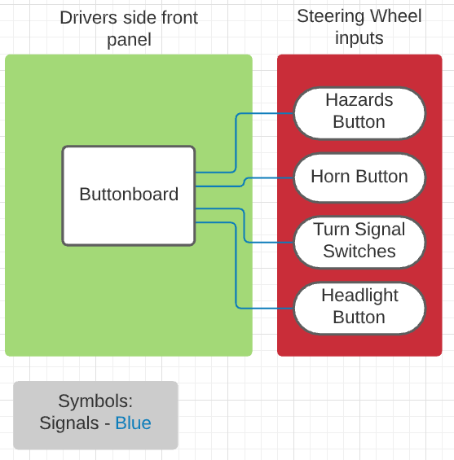

Figure 1. Buttonboard placement diagram

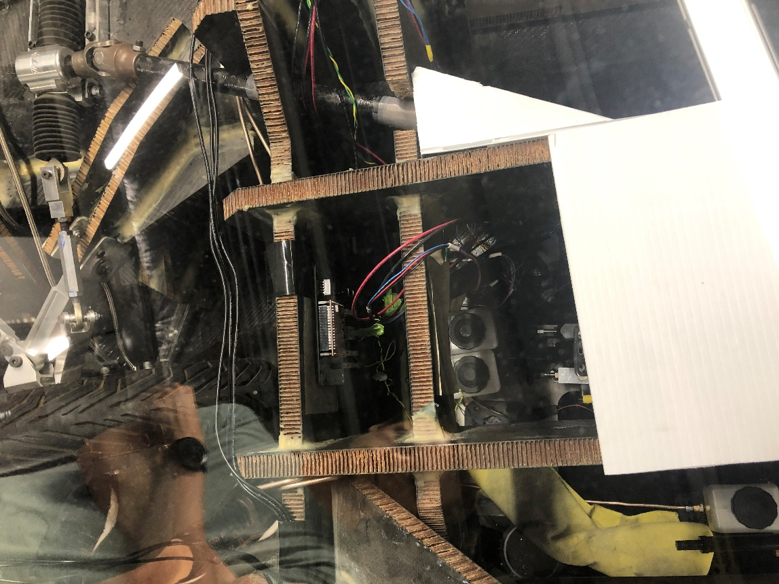

Figure 2. Buttonboard placement

## **Purpose**

the purpose of buttonboard is to provide an input driver interface for the car. The board will take in different inputs and send those signals to other boards through CAN to turn digital signals on or off for parts like our horn or turning lights.

# **Application**

## **System Level**

### **Block Diagram**

Buttonboard will get **12V_Main** voltage from powerboard. The inputs in buttonboard will be processed through CAN and sent to front and rear HAL to turn on different signals in the car like turn lights, horn, or hazard lights. Figure 3 demonstrates a block diagram showing how buttonboard gets power from powerboard and sends its CAN signals to the front and rear HAL boards.

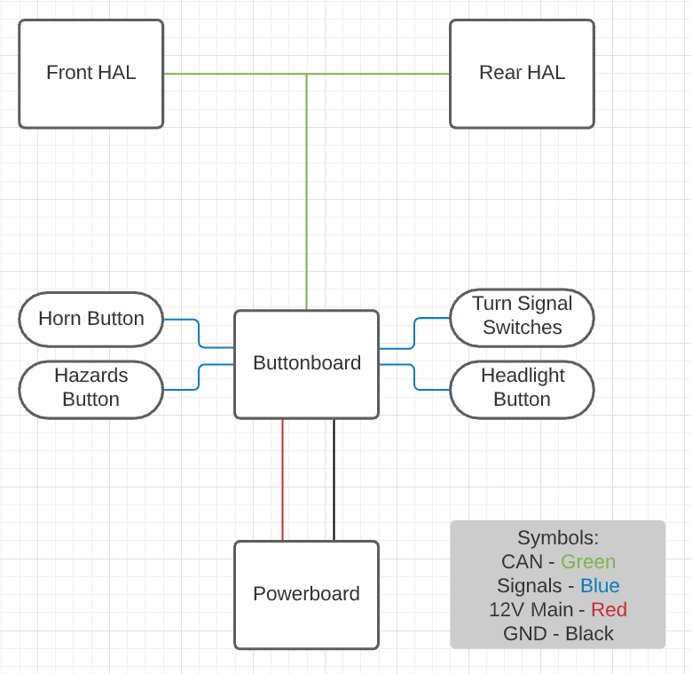

Figure 3. Buttonboard system diagram

### **Pin Diagram**

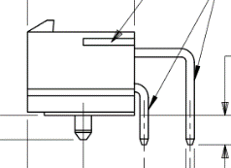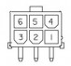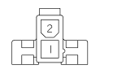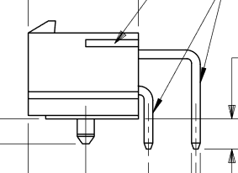

Figure 4. 2 pin connector diagram Figure 5. 6 pin diagram

A pin connection table is provided below for wiring purposes. In general, the wire with a greater voltage on it is connected to the lower pins, and the wire with a lower voltage on it is connected to the upper pins of a connector. The intention of wiring in this fashion is to decrease the chances of someone accidentally brushing the connector and touching the high-voltage signal.

Table 1: Pin diagram

|  |  |  |  |
| --- | --- | --- | --- |
| **Connector designator** | **Connector Type** | **Pin #** | **Description of Signal** |
| J1 – 12V_Main | Megafit | 1 – MGND  2- 12V_Main | 12V_Main from powerboard |
| J2 – 5V_INPUT | Minifit | 1 – 5V  2 – MGND | 5V input possibly needed for buttons. NOT CURRENTLY USED |
| J3 – CAN1 | Minifit | 1 – CAN_H  2 – CAN_L | CAN1 Connector |
| J4 – CAN2 | Minifit | 1 – CAN_H  2 – CAN_L | CAN2 Connector |
| J5 – Button Inputs | Minifit | 1 – Left Turn  2 – Right Turn  3 – Horn  4 – Running Lights  5 – Hazards  6 - Brights | Takes in inputs for different buttons and switches from the driver’s side of car |

To note here, right now we are not using both running lights and brights. When designing the board, we were unsure of if we would use both, so we have them labeled with different nets and inputs on connector **J5**. They are listed here since they are still a separate input in the schematic. It is now the case that Brights is being used now for cruise control, but that is not represented on the silkscreen on the board.

### **Mounting buttons on wheels**

There are 5 buttons attached on the driver’s wheel. The positive end of the buttons are wired through the **J5** button input connector and the negative end of the button is wired through a chain of ground wires that go around the wheel. The buttons on the wheel are left turn, right turn, horn, hazards, and cruise control. Left turn, right turn, cruise control, and the hazards buttons are all latching. For the sake of everyone’s ears, the horn is non latching, so it will not stay pressed down after pushed.

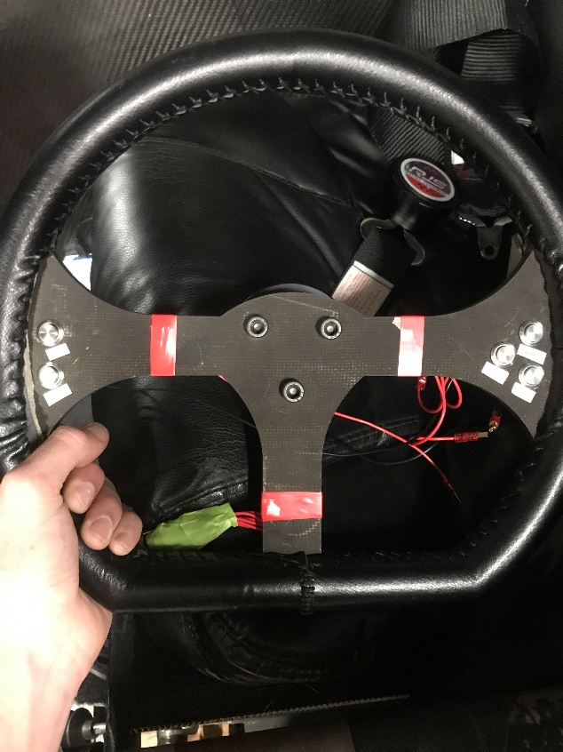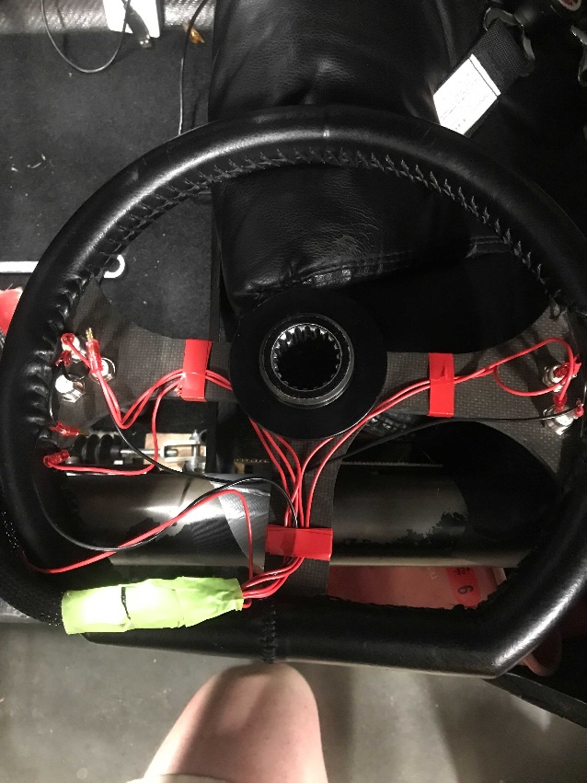

Figure 6. Back of wheel Figure 7. Front of wheel

## **Board Level**

### **Schematic**

Buttonboard’s schematic can be seen in Figure 10. For connectors, it should be noted that J1, the **12V_Main** connector, is a megafit connector instead of a minifit, unlike the other connectors. This is something that was changed across all the boards to help us from accidentally frying compute modules.

**Power**

The circuitry between the **12V_Main** megafit connector and the 5V switching reg, **U1**, is standard between a few different boards. Specifically, HAL and motorboard were designed around the same time as buttonboard and share a similar circuit and parts. The first PMOS, **Q2**, is used for reverse polarity protection. This is here so that just in case we accidentally swap our 12V and MGND inputs, we can’t accidentally burn anything up. Since we are using a PMOS, if our ground is connected in the right pin of the connector, pin 1, then the gate will enable the mosfet to send the 12V source from the drain (3 of **Q2**) to source (2 of **Q2**). **F1** is our fuse holder. If our fuse is blown or not connected, a second PMOS (Q1) will turn on the Fault LED indicator. **C1** is a decoupling capacitor that helps smooth out our input voltage into the 5V switching regulator. **D1** is a TVS diode that helps to prevent fast voltage spikes to protect our circuit.

U1 is our switching regulator that turns our 12V voltage into 5V. Because of the TVS diode (**D1**), we had a 0.7V drop in our input, which LED us to use **R1** and **R3**. These two resistors are used to adjust the output voltage to help us get as close to 5V as we can. Before we added these, we were getting around a 4.2 V output. After the switching regulator we have a 5V LED Indicator to show that the switching regulator is working as we need and to show that our 5V plane on top of the board has voltage on it.

The power filtering circuit, shown in Figure 8, helps us smooth high frequency noise from our 12V line coming into buttonboard. **FB1** is a ferrite bead, which can be used to filter out the unwanted noise. The capacitors after it are designed to be placed in decreasing order of capacitance and size. If you look at the PCB design, you will notice that **C1** and **C8** have a package size of 1206, **C9** has 0805, and **C10** has 0603. They also decrease in order of capacitance, which is easier to see on the schematic.

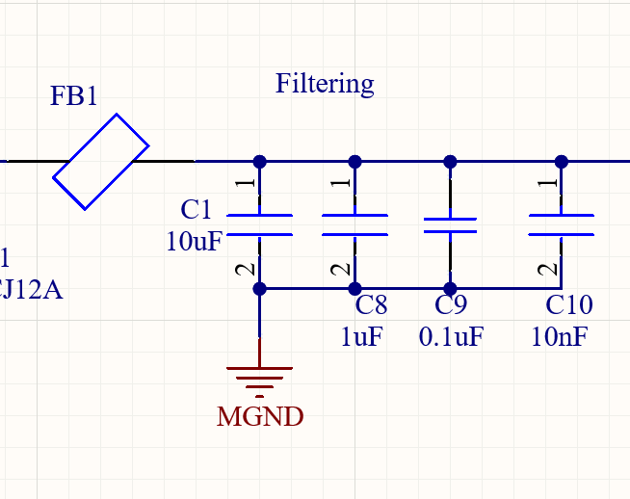

Figure 8. Power filtering circuit

**Connectors**

We have two connectors for can, which *can* be seen with the **J3** and **J4** connectors. These go into the CANH and CANL pins of the S+ (**U2**). For the input section, we have a 6 pin minifit connector, **J5**, used to get our actual button and switch inputs from the car. These inputs will then go into Port B pins of the S+.

**Pullup Resistors**

Each input is wired to a pullup resistor, as seen by **R4** for example. This makes it so that all the inputs will default to a logic high normally. **J2** as of now will not be used, but we kept it in as a 5V input just in case we needed it with the button inputs. This was added Fall 2020 and could possibly be changed for future revs.

**Input Debouncing**

Below, in Figure 9, is an example of an input debouncing circuit I created in falstad, an online circuit simulation app. On the left, between the 5V line and button, is our ordinary pull up resistor circuit we used in **Rev2** and previous iterations. Normally the MCU input would go between the Button and leftmost 1k resistor, and detect the change between 5V and GND. But now, we use a resistor and capacitor to filter this circuit. When you press a button down, the voltage doesn’t smoothly jump to 5V, as it will “bounce”. To counter this, we include a capacitor to take the “noisy” voltage that is constantly jumping as the voltage gets pulled down on a button press. This works because current through a capacitor is C times the change in voltage. So, after the voltage is “smoothed out”, the change in voltage will be extremely low, so barely any current will flow through the capacitor once it is filtered, leaving the voltage to cleanly be read by the microcontroller input.

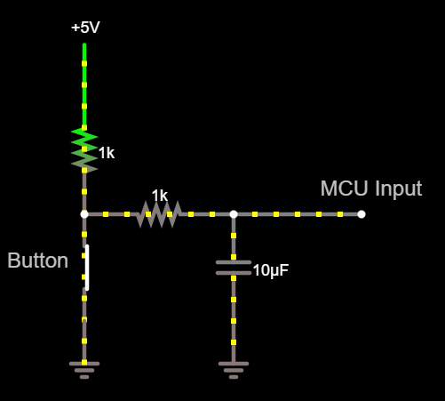

Figure 9. Input debouncing circuit

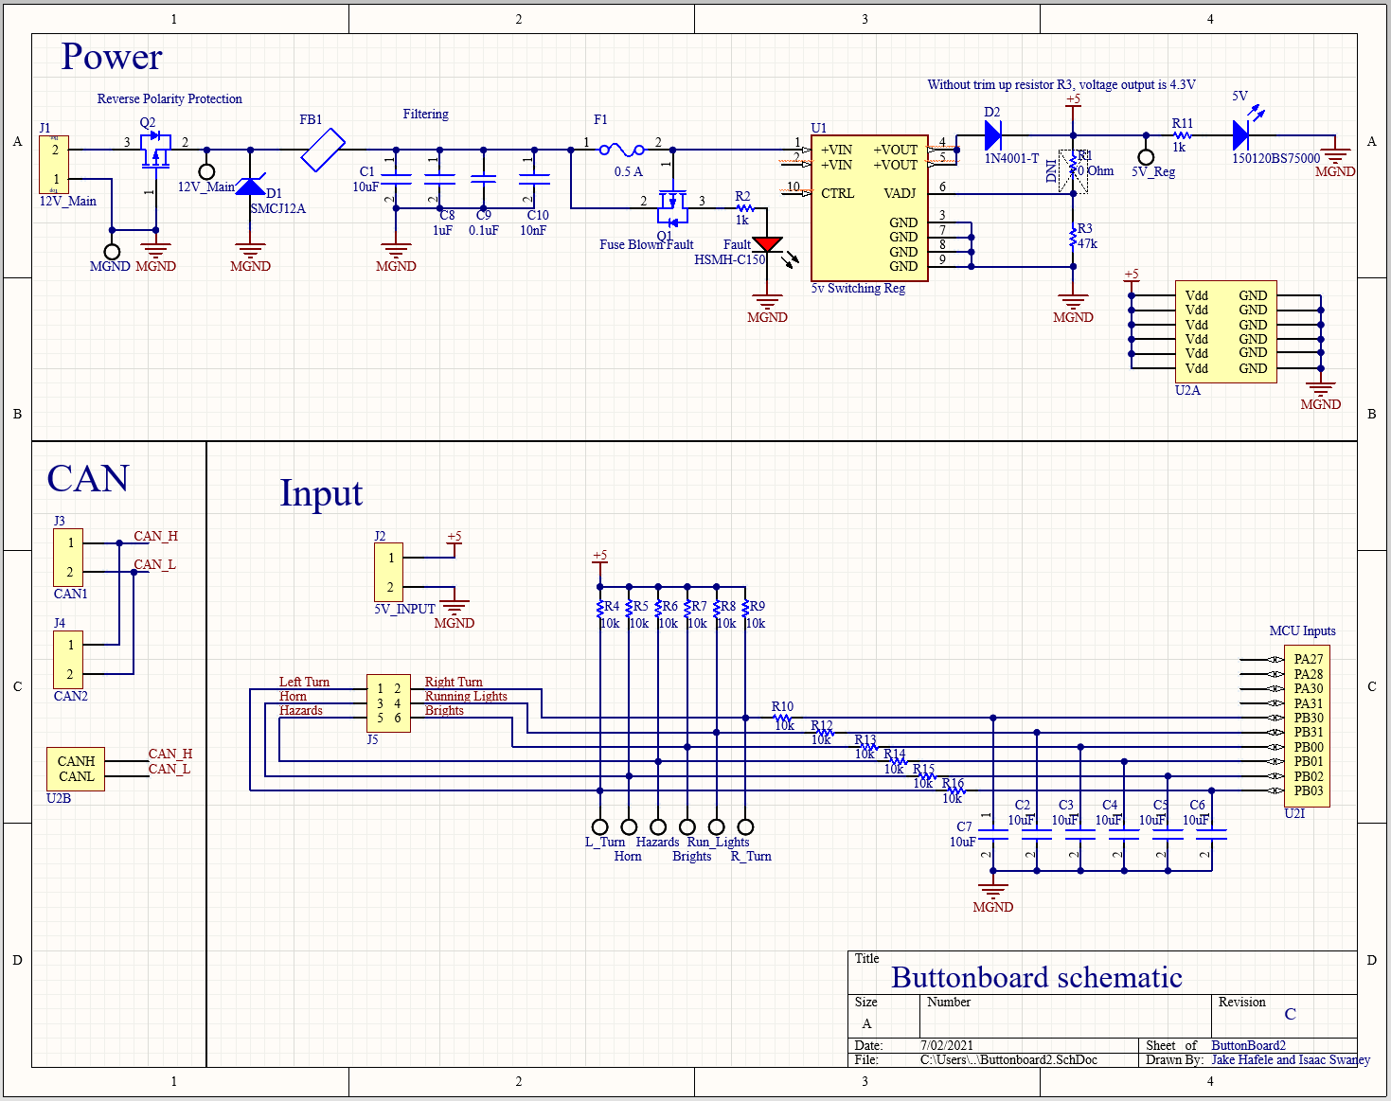

Figure 10. ButtonBoard.SchDoc

### **PCB Picture**

A picture of buttonboard’s PCB can be seen in Figure 11 below. The layout of the board is simple overall. On the left side of the board, we have our **12V_Main** connector and all our power protection and switching regulator. All the components to the left of the compute module relate to the Power section of the schematic. To note with this, Figure 12 shows the 0.5 A silkscreen that is used to denote what type of fuse we need in the fuse holder. The CAN connectors are on the top right of the board, and the button inputs can be seen to the left of them on **J5**. We aligned all the pull up resistors in between this connector and the compute near the middle of the board. We also added test points for a couple different things. We added test points for **MGND**, 5V, and **12V_Main** on the left side of the board so it is easy to see if our fuse and switching regulator are working as planned. We also added test points and labels for all our different inputs on the right of the board. We made it a point to include these on the sides of the board so they would be easy to probe and access. The only notable change of **Rev3** was adding the fill for a small ground plane between C1 through C10. We placed three vias throughout to plane to make sure ground was evenly covered in it, but it made it very easy to ground the capacitors for filtering.

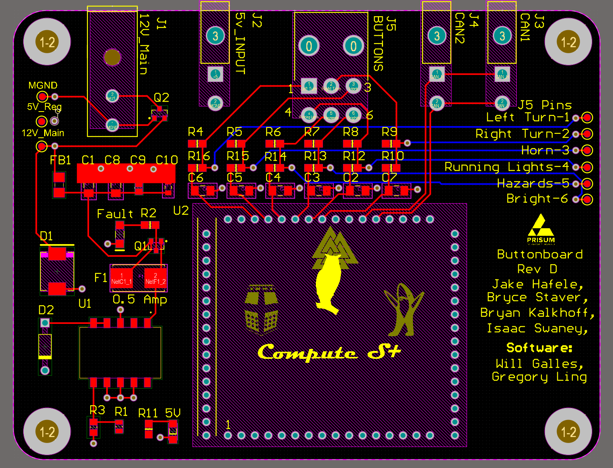

Figure 11. ButtonBoard.PcbDoc

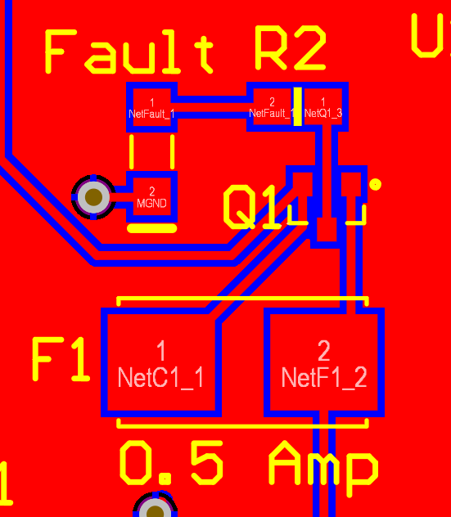

Figure 12. PCB Fuse and circuit protection block

### **Project Specifics**

Using Figure 13 we can find the correct trim up resistor to adjust the output voltage to match 5V. According to figure 14, if we include a diode before VOut we need to add that voltage drop onto **Vo**, which will be roughly 0.7V. After plugging in values of **R1**, **R2**, **R3**, **Vo**, and **VRef** for the values spec’d out at the 5V switching regulator, we get a trim up resistor of 47 kOhms. Based on the protection diagram in Figure 5, we do not need to include a trim down resistor, and only a trim up resistor. This is a mistake I made while testing during Rev B.

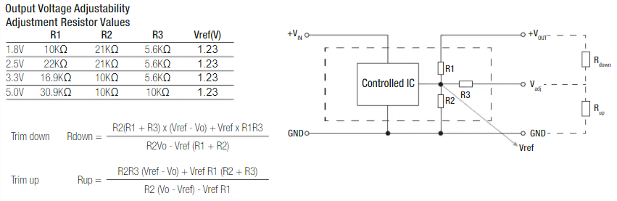

Figure 13. 5V Switching Regulator resistor equations

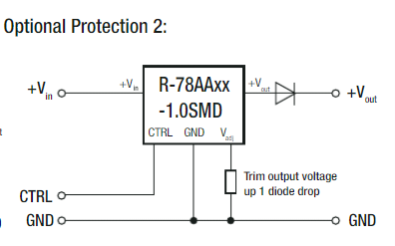

Figure 14. 5V Switching regulator diode protection

# **Proof of Operation**

## **Test Procedure**

Testing hardware for buttonboard Rev B and Rev C was very straightforward. Since Rev C only changed the **12V_Main** connector, testing was the same for both revs. After soldering all our parts on, we tested for continuity by probing different parts of the board. More specifically, we tested for continuity around our fuse and switching regulator, to make sure we would get our 5V out. We also tested the board plugged in without a fuse to make sure the Fault indicator would light up. After this, we probed the test points of the inputs to make sure that they were default high signals normally. We then grounded the inputs to make sure that the test points and the input lines would change to a low or 0 signal. This was the extent of our testing for buttonboard so far, and it will almost definitely be the same process when we get our new board for Rev C soon.

For testing buttonboard in the future, follow this checklist:

1. Does the power LED indicator turn on after providing a 12V source in J1?
2. Does the 5V switching regulator output 5V? This can be checked by probing the 5V and MGND test points. If not, try checking you placed the trim up resistor on **R3** and not **R1**!
3. Make sure ground is on the top pin of the connector (1) and the 12 V line is on the bottom (2). Refer to the 2 pin Minifit connector in the pin diagram above.
4. Test reverse polarity by swapping the 12V and ground line on **J1** and make sure the board DOES NOT turn on (Thanks to **Q2**)
5. Test the fuse blown circuit by making sure the **FAULT LED** turns on when you take out a fuse cartridge (Thanks to **Q1**)
6. Make sure the button inputs (test points on the right) are all about 5V by default (this is because they are pull up resistors, they will be grounded to 0V when pressed)
7. Celebrate because you just aced the best god damn board on this car

## **Test Results**

The only thing that was wrong with hardware during testing was that our output voltage from the 5V switching regulator was around 4.2 V. After looking at the schematic, we determined that this was because of the TVS diode before the voltage output, which was dropping the voltage. To fix this, we set the output voltage to 5.7V to account for the diode drop and calculate the trim up resistor based on Figure 4 and Figure 5.

## **Troubleshooting**

If any step of the test procedure failed, follow the troubleshooting for that step below:

1. Check if the fuse blown LED is on from a blown fuse, and check if the power LED is soldered on the right way with a diode check
2. Make sure you have the trim up resistor on the right trim pad and that it is the right value
3. To confirm this, check which pin is connected to the bottom layer/plane of the board which is ground. The pin closer to the inside of the board should be grounded.
4. Verify an N-MOS is on **Q2**
5. Make sure the fuse is out and the fault LED is facing the right direction
6. Same as step 2

## **Race Considerations**

If either the 0.5 A fuse on **F1** is blown or there is not a fuse in the fuse holder, the **FAULT** LED indicator will light up. This should never be on. Instead, the 5V LED indicator should be on if 12 volts goes through the switching regulator. Both are on the left side of the board and can be seen in the PCB in Figure 2. Only one should be on at once and should indicate the current condition of power through the board.

## **Future Considerations**

Standardizing parts between 2020’s new member projects were a big plus for buttonboard. When I was working on the schematic, it was helpful to share parts or circuit protection with other boards like HAL or motorboard. To note, many of the boards shared the same switching regulator and circuit protection, since these boards all had the same 12V input coming into them. This is something that makes life easier for people ordering parts and the people designing them. For future revisions of the board there might also be some worthwhile information in documentation from both HAL and motorboard.

Another small thing is to remember to buy fuses with your fuse holders. We forgot to do this for Rev B, since only the fuse holder was on our schematic. This is something currently in our BOM but could be forgotten easily if someone makes a fresh one for a change.

# **Additional Resources**

## **PrISUm Contacts**

|  |  |  |  |
| --- | --- | --- | --- |
| **Name** | **ISU Email** | **Personal Email** | **Phone** |
| Jake Hafele | jmhafele@iastate.edu | jakehafele@gmail.com | (309)-696-0228 |
| Bryan Kalkhoff | bryank@iastate.edu | bsk678@live.com | N/A |

# **Appendix**

## **Reference**

5V Switching Regulator Datasheet (**U1**) - <https://www.digikey.com/htmldatasheets/production/705190/0/0/1/r-78aa-1-0-series-datasheet.html>

## **Figures**



Figure 1. Buttonboard placement diagram



Figure 2. Buttonboard placement



Figure 3. Buttonboard system diagram



Figure 4. 2 pin connector diagram



Figure 5. 6 pin diagram

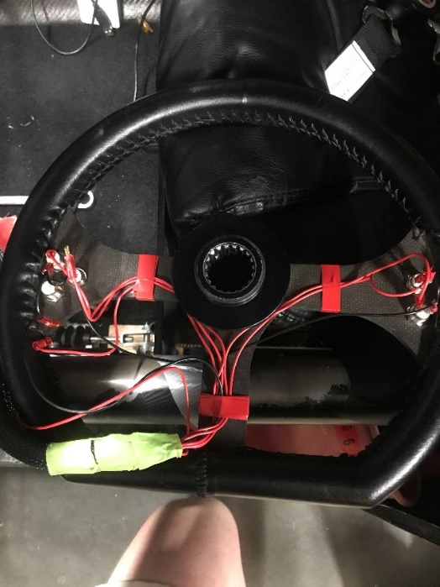

Figure 6. Back of wheel

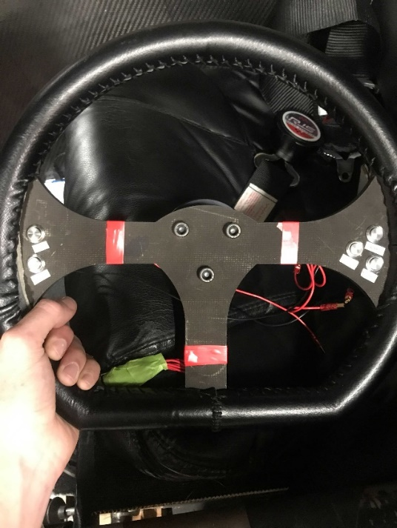

Figure 7. Front of wheel



Figure 8. Power filtering circuit



Figure 9. Input debouncing circuit



Figure 10. ButtonBoard.SchDoc



Figure 11. ButtonBoard.PcbDoc



Figure 12. PCB Fuse and circuit protection block



Figure 13. 5V Switching Regulator resistor equations



Figure 14. 5V Switching regulator diode protection

## **BOM List**

|  |  |  |  |  |
| --- | --- | --- | --- | --- |
| **Item #** | **Amount per board** | **Designator** | **Manufacturer Number** | **General Part** |
| 1 | 1 | J1 | 768250002 | 2 Pin Megafit |
| 2 | 3 | J2 J3 J4 | 39300020 | 2 Pin Minifit |
| 3 | 1 | J5 | 39295063 | 6 Pin Minifit |
| 4 | 2 | R2 R11 | CRG0805F1K0 | 1k Resistor |
| 5 | 1 | R3 | CRGCQ0805F47K | 47k Resistor |
| 6 | 12 | R4 R5 R6 R7 R8 R9 R10 R12 R13 R14 R15 R16 | RMCF0805FT10K0 | 10k Resistor |
| 7 | 1 | 5V | 150120BS75000 | Blue LED |
| 8 | 1 | Fault | HSMH-C150 | Red LED |
| 9 | 1 | F1 | 01550900M | Fuse Holder |
| 10 | 1 | F1 | 0451.500MRL | Fuse |
| 11 | 1 | D1 | SMCJ12CA | Diode |
| 12 | 1 | D2 | 1N4001-T | Diode |
| 13 | 1 | U1 | PPPC161LFBN-RC | Compute Female headers |
| 14 | 7 | C1 C2 C3 C4 C5 C6 C7 | CL31A106MOHNNNE | 10 uF capacitor |
| 15 | 1 | C8 | 12065G105ZAT2A | 1 uF capacitor |
| 16 | 1 | C9 | 08055C104JAT2A | .1 uF Capacitor |
| 17 | 1 | C10 | C1608X7R1H103K080AA | .01 uF Capacitor |
| 18 | 1 | FB1 | HI1206N800R-10 | Ferrite Bead |
| 19 | 2 | Q1 Q2 | AO3419 | PMOS |